Practice 11.1.1
Write a Python program that reads an integer, calculates the sum of its digits, and prints the result.
Algorithm:-
- Start.
- Input: Prompt the user to enter an integer and store it in the variable num.
- Initialize: Set the variable digit_sum to 0.
- Absolute Value: Convert num to its absolute value using abs(num) to ensure the logic works for negative numbers.
- Looping Condition: While num is greater than 0, repeat the following steps:
  - Extract Digit: Find the last digit of the number using the modulo operator
  - Accumulate: Add this digit to the digit_sum.
  - Update Number: Remove the last digit from num
- Output: Once the loop terminates (when num reaches 0), print the final value of digit_sum.
- Stop.
FlowChart:-

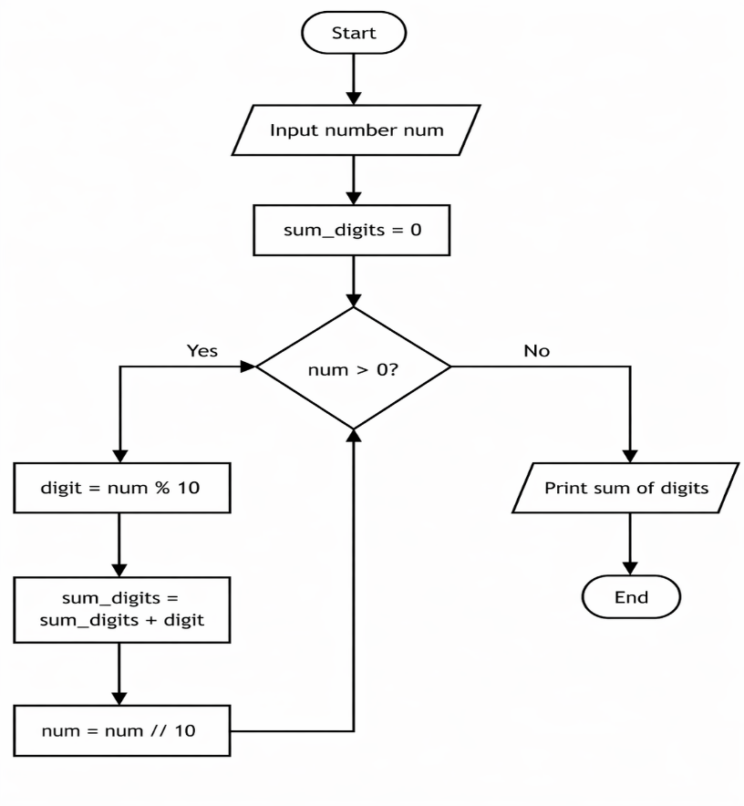

Code:-
